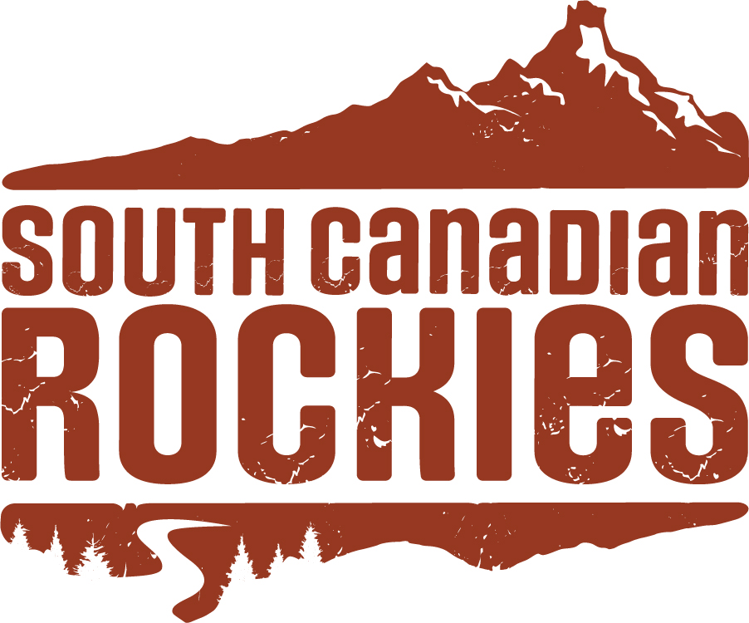

South Canadian Rockies Tourism Association
Shoulder Season Enhancement Fund
Fall 2026 Intake Application Form

Program Overview
The South Canadian Rockies Shoulder Season Enhancement Program provides financial support to regional businesses and organizations who are seeking to expand tourism revenue through initiatives such as events, experiences, and product development.

Initiatives must support destination development during either of the shoulder seasons.

Fall Shoulder Season – Activities must take place between September 13 and December 31.
Winter Shoulder Season – Activities must take place between February 1 and May 31.

Eligible Applicants
Support will be awarded to members based on their application. Applicants must be active members of the South Canadian Rockies Tourism Association, in good standing.

Applications should showcase programs, events, or experiences that will enhance shoulder season revenue and maximize regional economic impact within South Canadian Rockies. Programs that focus on increased overnight stays, bolstered or improved experiences, and development of product will be prioritized.

Program Details
- Maximum of one application per organization.
- Funding cap of $2,500.
- Post-program reporting should indicate favourable results in overnight stays or increased revenue during shoulder season for successful operators and will be required 15 days after the program completion, unless otherwise specified by the selection committee.

Eligible Expenses
Logistical and production costs (for example: performers, artists and artisans fees; rental of security barriers, equipment, tents, lighting, sound equipment, venue; permits and insurance; product enhancement such as website development or program expansion).

Promotional support (for example: targeted online ads as part of an integrated, multi-faceted marketing campaign; radio/media/print advertising that presents a unified tourism message; content development including photography, video and written content — a shot list must be included with the application).

Ineligible Expenses
Event sponsorships, fundraisers, contests; salaries and wages of employees; purchasing of goods and services for resale; capital purchases; alcohol permits and alcohol; accommodation; hosting; ticket surcharges; donations; prizing and gifting (including volunteer apparel/swag); and costs which South Canadian Rockies, at its discretion, deems ineligible.

Requirements
- Expenses must be incurred between the dates outlined in this program description.
- Expenses must be invoiced by a qualified third party and documented in post-program reporting.
- A minimum number of social media posts (as determined by SCR) including placement of the SCR logo must be included in promotions of the event.

APPLICATION FORM

1. Are you a member of South Canadian Rockies Tourism Association (SCR) in good standing? *
[ ] Yes
[ ] No

2. Please list the name of your business and your full name (the full legal name of the applicant). *
Business/Organization Name: ________________________________
Applicant Full Legal Name: ________________________________

3. Mailing address of applicant and business. *
Mailing Address: __________________________________________
City/Town: ________________________________________________
Province: ___________________ Postal Code: _________________

4. Phone number. *
Phone: ___________________________________________________

5. Website link. *
Website: __________________________________________________

6. Project information. *
Please provide an overview of what you are planning for Shoulder Season enhancement in South Canadian Rockies, including project dates (between September 13 and December 31, 2026), and indicate if this is a new or existing initiative.

Project Overview:

Project Dates (between Sept 13 and Dec 31, 2026):
Start Date: __________________ End Date: __________________

New or Existing Initiative (please describe):

7. Program budget and funding request. *
How much funding are you requesting and what percentage does this funding make up of your total project budget? (Basic budget only.)

Total Project Budget: $____________________
Funding Requested from SCR: $____________________
SCR Funding as % of Total Budget: _______________%

Brief Budget Summary/Explanation:

8. Funding information.
Please list the items/initiatives that South Canadian Rockies funding will be used for, and anticipated cost.

Item / Initiative Anticipated Cost
____________________________________ $____________________
____________________________________ $____________________
____________________________________ $____________________

9. If you receive no funding, or only partial funding, from South Canadian Rockies, will you be able to continue on with your project? *
[ ] Yes
[ ] No
Brief explanation:
__________________________________________________________
__________________________________________________________

10. Partner information. *
Please list any partners that you will be working with (partners can include municipal partners, other community organizations, and/or local operators). Please explain capacity of partnership.

Partners and Roles:
__________________________________________________________
__________________________________________________________
__________________________________________________________

11. Marketing information. *
Please describe how you plan to advertise/market your program, and indicate what percentage of your marketing will be focused on audiences outside the SCR region.

Marketing Plan:
__________________________________________________________
__________________________________________________________

Estimated % of marketing focused outside SCR region: ________%

12. Marketing information (audience). *
Who is your audience and what type of visitor are you aiming to attract?

Target Audience and Visitor Type:
__________________________________________________________
__________________________________________________________

13. Anticipated program audience by percentage. *
Please indicate your anticipated program audience by percentage:
Southern Alberta including Calgary: ________%
Rest of Alberta: _________________________%
Out of Province: _________________________%
International: ___________________________%

14. Additional required documents. *
Please indicate the status of required supporting documents (required - one letter of support from an independent organization or business and; any letter(s) of confirmation from partners described in your application.

[ ] Yes, I have attached these documents.

15. Key Performance Indicators (KPIs). *
Please list your key performance indicators and how you plan to record them for post-program reporting.

KPIs and Measurement Methods:
__________________________________________________________
__________________________________________________________
__________________________________________________________

16. Declaration. *
I have read the declaration below and understand it.

The Applicant declares that the information contained in this application, and any supporting documents, is true and accurate. The Applicant understands and agrees that should this application be approved, any funding awarded is subject to the Applicant complying with the terms and conditions of the agreement and post-program reporting requirements.

Applicant Signature: ____________________________ Date: ________________

Completed applications and supporting documents may be submitted to:
info@southcanadianrockies.ca
SUBJECT LINE: Completed Shoulder Season Grant Application

Thank you for your interest in the South Canadian Rockies Shoulder Season Enhancement Fund – Fall 2026 Intake.

